# Iteration 1

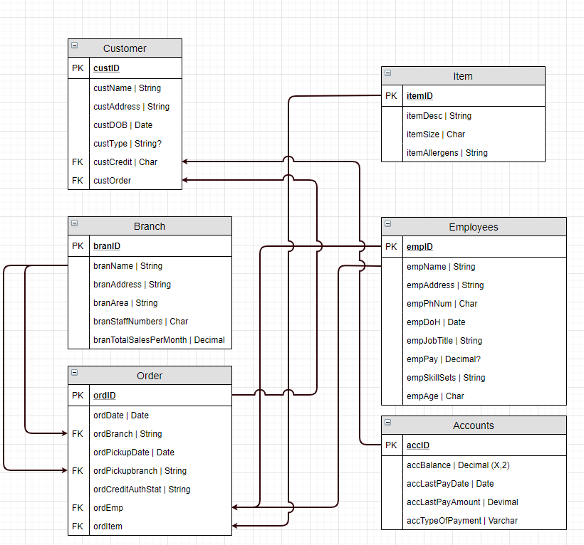

With this iteration I had made an ERD diagram that has no Multiplicity on it making it more of a dataflow table instead. Attributes were also included in this as well as the Primary Keys and Foreign Keys. This was based on the information given in the PDF file. I did make another ERD similar to this one but due to the minimal changes between the two I decided to disregard that ERD and keep only this one.